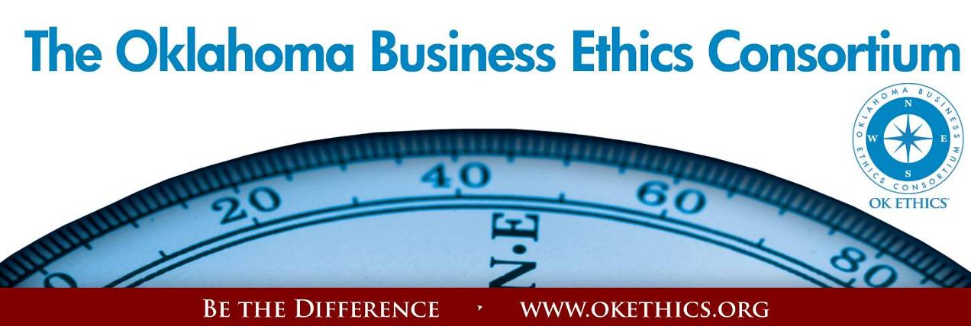

***ENTERING OUR TENTH YEAR OF PROMOTING OKLAHOMA VALUES OF INTEGRITY AT WORK!*Agenda – December 7, 2012**

1. **Welcome –** *Shannon Hiebert***,** *Vice President of Human Resources, Enterprise Holdings;   
    President, OK Ethics Foundation* **● New Members and the Manby family from Norcross, Georgia**

**II. Kudos –**

**● Co-hosts: Strata Leadership   
 ● OKLAHOMA SWEEPS TEXAS REGIONAL ETHICS BOWL** *- Chaz Carter, Oklahoma Christian*

**Oklahoma Christian University, 1rst & 3rd place**Advisor: Professor Jeffrey Simmons   
Team Members: Chas Carter, Austin Hughes, Brandon McWaters, Hannah Ketring   
 and Christian Asbill **University of Oklahoma, 2nd place:**  Advisor: Dr. Steven Ellis

**Oklahoma City University, 4th place:** Advisor: Dr. Barbara Crandall

**Universities representing Oklahoma:** Cameron University, Oklahoma Christian, University of Oklahoma, University of Central Oklahoma, Oklahoma City University  
  
**Corporate Judges & Moderators:** Shannon Hiebert (Enterprise Holdings); Colin Schoonover, (ONG); Tony Blasier, and Jack Rosenthal (Chesapeake Energy)  
  
Student efforts are supported by members’ dues as well as through the generous contributions provided by Chesapeake and Enterprise Holdings. Special thanks to OK Ethics Board member Bob Byrne who made a $10,000 contribution last year in memory of his late wife, Jeanne Byrne. We are deeply grateful for their continued support!

● **Volunteer Appreciation**

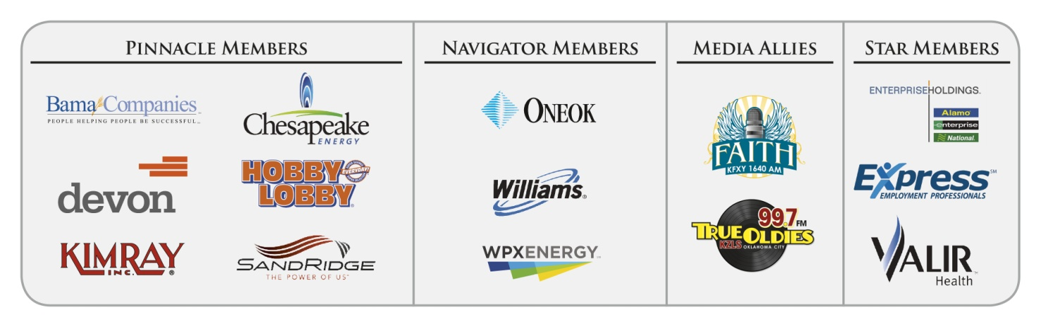**III. Upcoming Events -** *Shannon Warren, Founder, OK Ethics* **IV. Introduction –***Bob Byrne, Chief Diplomat, OK Ethics Consortium Board of Directors (Retired USAF & Boeing)*  **Keynote: Joel Manby, President and CEO, Herschend Family Entertainment Corporation  
 *Love Works!* Book signing immediately following program;** Make $20 checks payable to HFE

**Intentional Interaction Discussion Topic:**  **Who is/was your best boss? If you were to thank them for something they taught you, what would it be?   
*Note:*** *OK Ethics encourages interaction among our members for the purpose of building relationships with others who share an interest in promoting Oklahoma values of integrity at work. At the same time, this is not an appropriate forum for sales activities.*

**VOLUNTEER APPRECIATION:**

**OK Ethics relies primarily on volunteers to achieve the organization’s successful pursuit of Oklahoma’s values of integrity at work. It takes leadership and teamwork to host these exciting events and we salute your dedication in achieving OK Ethics’ mission! Listed below are today’s volunteers who consistently provide service to our members:**

**Ambassador Team:** These friendly people welcome our guests each month and assist in helping them locate seats. They also arrive early to help distribute agendas and assist with name tags.

|  |  |  |  |
| --- | --- | --- | --- |
| **Linda** | **Streun** | Ideal Homes | Chief Ambassador |
| **Brent** | **Martens** | Accounting Principals | Ambassadors (Lead – Team 1) |
| **Wayne** | **Hart** | Legal Shield | Ambassadors |
| **Tammy** | **McKeever** | Enterprise Holdings | Ambassadors |
| **Ben** | **Robinson** | SentryOne LLC | Ambassadors |
| **Connie** | **Root** | Walker Companies | Ambassadors |
| **Lynn** | **Willis** | Metro Technology Centers | Ambassadors |
| **Nancy** | **Hyde** | Hyde & Company, CPA's | Ambassador (Executive Team) |
|  |  |  |  |

**Registration Team:** These dependable individuals diligently record our guests’ attendance and handle the collection of fees:

|  |  |  |  |
| --- | --- | --- | --- |
| **Joe** | **Walker** | Arledge & Associates | Guest Registration (Prepaid Chair) |
| **Deborah** | **Burroughs** | Langston University | Guest Registration (Prepaid) |
| **Bobby** | **Redinger** | Cole & Reed | Guest Registration (Prepaid) |
| **Mary** | **Vaughan, CPA** | JMA Energy | Guest Registration (Cash & Visitors) |

**Agendas:** Many thanks to the volunteers from Metro Technology Centers who provide our monthly agendas.

**Special Initiatives:**

|  |  |  |  |
| --- | --- | --- | --- |
| **Susan** | **Pate** | Stinnett & Associates | Accountant |
| **Michael** | **Mount** | Oklahoma Accountancy Board | CPE's |
| **Jamie** | **Potter** | Eide Bailly LLC | Facilities & Logistics Chair |
| **Jalisha** | **Petties** | OK Ethics | Member Care Coordinator |
| **Anna** | **Rosenthal** | OK Ethics | Special Projects & Name Tags |
| **Shirley** | **Mears** | Champlin Broadcasting | Announcements on the Morning Drive (99.7) |

***MC900187159[1]***

***TUNE IN!***  *Our own* ***Bob Byrne and Shirley Mears*** *featured on the morning drive for* ***True Oldies Channel FM 99.7*** *– Tune in between 7:00 and 8:00 a.m. to learn more about Oklahoma’s legacy! Also, hear interviews with speakers thanks to Champlin Broadcasting!*

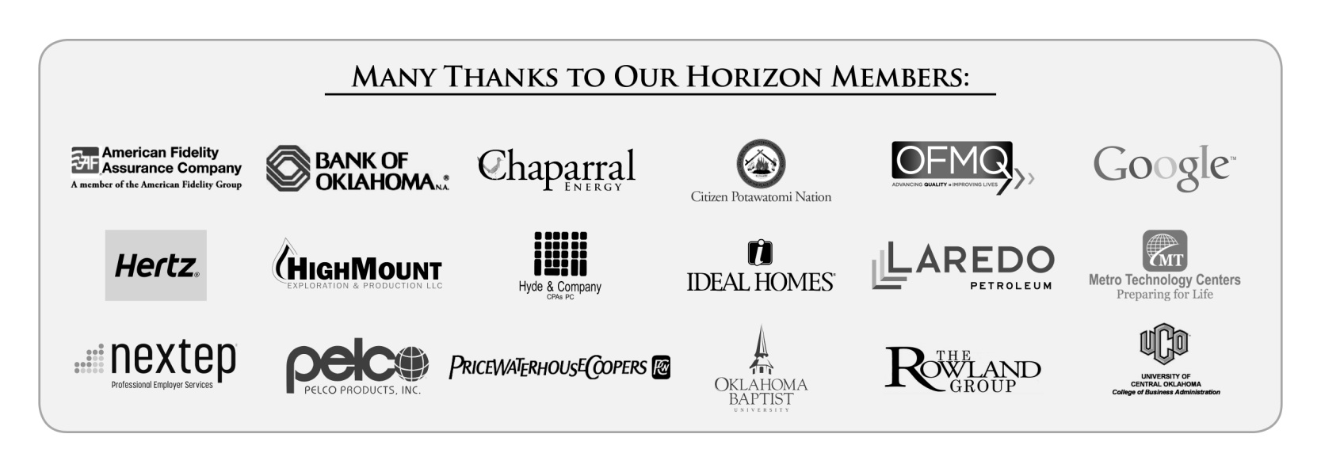**New Member Appreciation:**

* **Laredo Petroleum - (Horizon - Tulsa)**
* **John B. Davis & Associates - (Trailblazer – OKC)**
* **Legends Senior Living - (Trailblazer – OKC & Tulsa)**
* **LynnCo Supply Chain – (Leading – Tulsa)**
* **Dove Science Academy – (Frontier – OKC)**
* **Hudiburg Auto Group – (Frontier – OKC)**
* **First Bethany Bank – (Scout – OKC)**
* **Holy Temple Baptist Church – (Scout – OKC)**

We appreciate all that our contributors do to promote business ethics in our Oklahoma communities. Members’ support resulted in the following achievements last year:

* **An average of 450 business leaders and professionals in attendance at monthly programs focused entirely on business ethics.   That’s an increase of nearly 100 participants this past year!**
* **Thanks to you, we are now able to bring in internationally-known speakers, in addition to programs presented by local heroes.** This past year, we welcomed leaders such as **Chuck Colson and General Tommy Franks.**  Our annual Compass Award was the largest ever and featured the renowned business leader, consultant and author **Stephen M. R. Covey**.  It was a major milestone for us!  
    
  In November, we will kick off a year-long celebration toward our tenth anniversary with keynote speaker, **Harry Paul.  He is one of the authors for the best-selling book, *Fish!***
* **This year, we found it necessary to retain some part-time workers, but most of our work continues to be** performed by a dedicated group of volunteers.  By spreading the work among these passionate individuals, we are able to maintain the lowest possible overhead while continuing to deliver valuable services to our business community.   The ROI is significant as we provide numerous continuing education programs that are consistently high in quality.
* **Finally, our outreach to university students has greatly increased.** Part of your membership dues are earmarked to sponsor **student ethics activities on thirteen Oklahoma campuses** and our Foundation recently sponsored a **Statewide Educators Ethics Symposium** that was attended by approximately 70 academic leaders representing nearly 20 educational institutions.

**Upcoming Events: Oklahoma City Chapter**  *Shannon Warren, Founder, OK Ethics*

|  |  |
| --- | --- |
| **Wednesday, January 9, 2013 Petroleum Club – OKC** | **Wednesday, February 13, 2012**  **Petroleum Club - OKC** |
| **“Overcoming Contention  and Divisiveness”**  ***presented by***  **Wes Lane Former OKC District Attorney and**  **President, Salt and Light Leadership Training, Inc.**    ***Introduction by current OKC District Attorney, David Prater*** | **“What in the World is Going On?”**    ***presented by***  **Lori Tansey Martens**  **President & Founder, International Business Ethics Institute Washington D.C.** |
| **wes Photo.JPG**  **Help spread the word: Please post Upcoming Events on your company’s bulletin board.** | lori Tansey Martens head shot.JPG |

**Programs Focused on Integrity - (Not affiliated with OK Ethics)**

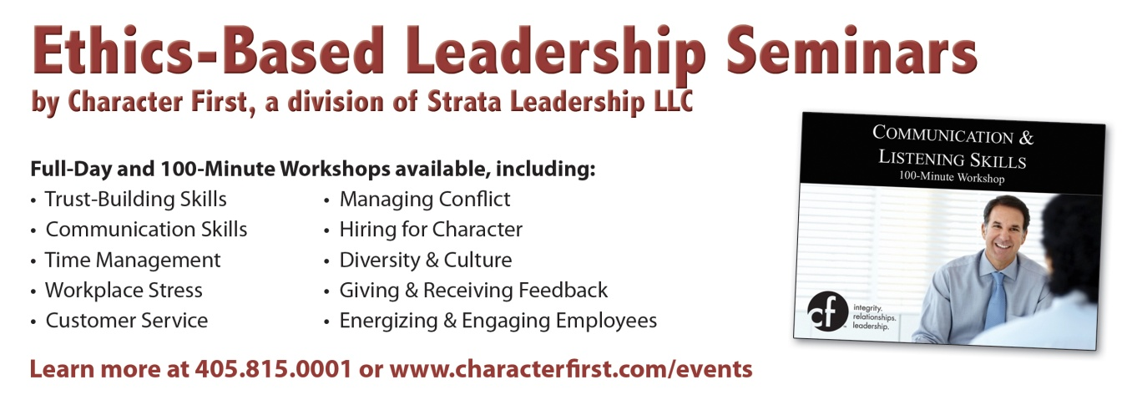Since the beginning, OK Ethics members have been inspired by our friendship with Character First. Leaders with this organization provided the wisdom and insight for OK Ethic's Guiding Principles. Go to [www.characterfirst.com](http://www.characterfirst.com/) to learn more about tools to help you integrate character and ethics into your organizational culture, or contact John Burnett at [405-815-0001](tel:405-815-0001)

**Character Council of Central Oklahoma** …cultivating good character

The Character Council of Central Oklahoma is an organization that educates, equips and empowers others to create a culture of good character within Central Oklahoma. Their vision is that Central Oklahoma will become a model community of good character.  
 **Topic: Deference  
Presenter: Lauren Nelson  
Date: December 18**

**Cost is $20 per person; Reservations made via** [luncheon@characterok.org](mailto:luncheon@characterok.org)

***Interested in Receiving OK Ethics Monthly Meeting Notices?***

***OKC:   
Contact Jalisha Petties, Member Care Coordinator***

***at (405) 889-0498 or via email*** [***okethics@yahoo.com***](mailto:okethics@yahoo.com)

***Interested in joining OK Ethics?***

***Contact Lynda Mobley, Vice President of Membership***

[***Lynda.Mobley@oneok.com***](mailto:Lynda.Mobley@oneok.com)

**LIKE OK ETHICS ON FACEBOOK**



**Joel Manby, President and CEO,   
Herschend Family Entertainment Corporation,**

***Many thanks to our friends at Strata Leadership for making this event happen!***

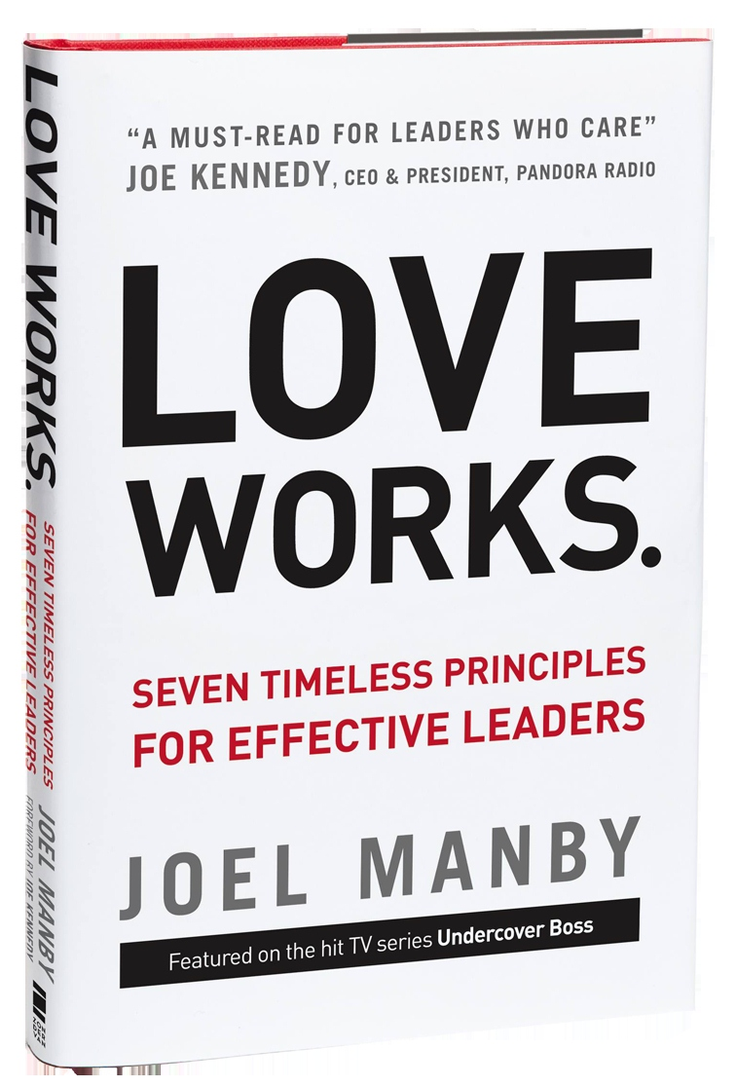**Program** Overview

Introduction

Patient: Have Self-Control in Difficult Situations

Kind: Show Encouragement and Enthusiasm

Trusting: Place Confidence in Someone

Unselfish: Think of Yourself Less

Truthful: Define Reality Corporately and Individually

Forgiving: Release the Grip of the Grudge

Dedicated: Stick to Your Values in All Circumstances

A Choice You Make

Reference: Joel Manby Bio

# Overview *Love Works.*is a framework for successful leadership. It outlines a counterintuitive but proven path to success through a passionate and motivated workforce. The mainstay of this philosophy is leading with love, which relies on seven time-proven—but unfortunately not-so-often tested—principles that break down the natural walls within corporate cultures, empower managers and employees, disarm difficulties, and cultivate an atmosphere that builds long-term success.

The key to leading with love is turning love from an emotion into an action. This shift fosters strong relationships, which in turn builds enthusiastic employees and leads to enthusiastic customers. Using love at work also leverages the undeniable truth that love builds healthy relationship at home, so why not use the same behavior to build healthy relationships at work? The book will explore the seven principles of love, which are patient, kind, trusting, unselfish, truthful, forgiving and dedicated.

Joel Manby is proof that leading with love works. He has refined and relied upon this leadership philosophy for more than a quarter-century—first as a highly successful corporate executive at Saturn, then as Saab North America’s CEO, and most recently as president and CEO of Herschend Family Entertainment (HFE). At HFE, Joel and his team have proven you can get financial results *and* lead with love, generating a 14% annual return to shareholders in the 10 years he has been CEO while also helping hundreds of employees in financial need via the company’s Share It Forward Foundation. In 2010, HFE was featured in the CBS hit show *Undercover Boss*. Overwhelmed by the response of the 18 million viewers who loved seeing love in action, Manby decided to write this book.

**REMINDER: PLEASE PICK UP CPE’S   
AT CONCLUSION OF EVENT.**

## Introduction

I didn’t always believe in using love at work. It has been a journey to get to this state of understanding. There is a saying that “If you want to make God laugh, tell him your plans.” I planned to be an internet pioneer and move to California with my family. But God had other plans for me. With one phone call, a new plan came into being.

That phone call was from Jack Herschend. On a cold lonely night, he invited me to be chairman of the board at Herschend Family Entertainment. And that began my new career in the theme park industry and my new outlook on work. Jack and his brother Peter, led HFE with love. They had created a successful business where they loved their employees and their employees loved them. This business model was eye-opening to me. It had been what I had always craved.

With their guidance, I transitioned from a numbers only-focused leader to a servant leader. I have learned that you can identify and maintain a strong culture built on timeless values while at the same time achieving strong financial results. I learned how to lead with love.

## Patient: Have Self-Control in Difficult Situations

* Don’t be patient with poor performance. Be patient with how you respond to poor performance.
* Praise patiently in public.
  + Be specific and exact.
  + Be legitimate—false praise kills credibility.
* Admonish in private.
  + Private admonishment is effective and protects a person’s dignity.
  + Get to the point and be specific; reaffirm the person’s value; get the person “back on the horse”; and don’t speak of the reason for admonishment again.
  + Praise more than you admonish—think in terms of a 3 to 1 ratio.

## Kind: Show Encouragement and Enthusiasm

* The enthusiasm of the guest experience can never rise higher than the enthusiasm of your employees.
  + Kindness, encouragement, and enthusiasm start at the top.
  + When a leader is kind, it will influence frontline employees who interact directly with the customers.
* Make their day better.
  + Every time you contact someone, you can make their day better or worse—so make it better.
  + Making a day “better” sometimes requires very little action or effort.
* Write ’em up.
  + Break through the email clutter and use handwritten notes of thanks.
  + Begin each day reflecting on the previous day, thinking about what you want to reinforce. Consider writing supporting notes to spouses as well.
  + CEO = chief encouragement officer. All of us can be a “CEO” under those terms.

## Trusting: Place Confidence in Someone

* Listening carefully is a sign of trust. Interrupting people is a sign of distrust.
* RACI is a trust tool to involve others in the decisions that affect them.
  + Use it to clarify who needs to be involved in a decision.
  + Although involving those affected by a decision may take more time than an autocratic decision, the total time through implementation will usually be shorter.
* Don’t just define the decision making process—follow it.
  + Let others make the decisions they are responsible for.
  + Avoid overriding a decision that has already been made unless it is absolutely necessary.

## 

## Unselfish: Think of Yourself Less

* Be unselfish with your personal treasure.
  + Define a fixed percentage of your income to give away.
  + Ask someone like your tax accountant to hold you accountable.
  + Set a finish line so you don’t have lifestyle creep.
* Be unselfish with your personal time and talent to make yourself, your organization, and the world better.
* Help your organization be unselfish.
  + Give a fixed percentage of your organization’s profits to help those in your organization who are in a personal crisis.
  + Give your time and talent to develop internal leaders.
  + “Do for one what you wish you could do for everyone.”
* Be unselfish with your decision-making authority: a strong leader should aim to make as few decisions as possible.
* Socratic, rather than autocratic, leading is more effective, because it leads to better decisions and attracts and keeps better talent.
* Socratic leading requires:
  + asking more questions
  + facilitating a team discussion with talented people
  + making the best decision possible due to rich discussion
  + summarizing the decision and direction

## Truthful: Define Reality Corporately and Individually

* Be truthful about the organization.
  + Don’t “shoot the messenger” or confuse conflict with disagreement.
  + Don’t assume people see the truth—speak up.
  + As a leader, it’s usually best to speak last.
  + Consider using a decision-making matrix in more complex organizational decisions.
* Be truthful to an employee.
  + Same as/More of/Less of is an effective tool to communicate the truth.
  + The same technique can be used in a larger group.
  + Getting at the truth keeps the best people and creates the best decisions.
* Be truthful in a dismissal.
  + It should not be a surprise to the person being dismissed.
  + Handle the tough day in a dignified manner.
  + Be proactive in giving the person you are firing advice and helping that person get his or her life back on track.
  + Be gracious. Letting somebody go should be painful so that you do it less often.
* Be open to hearing the truth.
  + No matter how you do it, find an accountability partner or partners in your life who will always tell you the truth about yourself.
  + Don’t guard Magic Johnson in a high school basketball game!

## 

## Forgiving: Release the Grip of the Grudge

* What was done to you doesn’t matter in the end—all that matters is how you respond.
* Forgive those who have wronged your organization.
  + Consider giving them another chance if it is a one-time offense, they are aware of their shortcomings, and they want to improve, or if you have any doubt about letting them go.
  + Be slow to fire and quick to forgive.
  + Forgiving someone and offering a second chance doesn’t always work out well, but consider it anyway.
* Forgive someone who has wronged you.
  + The longer you hold a grudge, the longer the grudge has a hold on you.
  + Forgiveness releases you to focus on love and relationship, not anger.
  + Forgiveness can release the person you forgive and give that person a fresh start.
  + Forgiveness has a positive ripple effect that often extends far beyond our comprehension.**Dedicated: Stick to Your Values in All Circumstances**
* Great leaders need to use both love and power.
  + Jesus displayed how to have power but show love.
  + Love without power and power without love are ineffective and unhealthy in relationships or organizations.
* Great leaders know how to reward people.
  + Measure both be goals and do goals.
  + Integrate be and do goals in your organization’s leadership development process.
  + Consider a 2 x 2 matrix to evaluate leaders.
* Great leaders know how to navigate in tough times.
  + It is possible to lead with love in the difficult times, but it takes dedication to the cause.
  + Leaders must make difficult decisions; how they handle those decisions separates those who lead with love from those who don’t.

## A Choice You Make

* Why don’t more organizations and leaders lead with love?
  + It’s hard. It’s easier to just “hit the numbers” without regard to how the decisions impact others.
  + It’s less about hitting the numbers and more about doing the right thing for the customer and employees over time.
  + Great leaders don’t build to flip—they build to last.
* Everyone matters.
  + You can have a strong influence on your organization no matter what position you hold.
  + Everyone in your organization is dealing with something. Leading with love will help people get through their struggles.
* Do versus be in all things: model a lifestyle of leading with love.
  + Be goals are completely within your power to execute.
  + Schedule time for your be goals just like you do for your do goals.
  + True contentment comes when we act in alignment with one set of values at work, at home, and in the community.

## Reference: Joel Manby Bio

Joel Manby is president and CEO of Herschend Family Entertainment Corporation (HFE), HFE is the premier privately held theme park operator in the United States and the 9th largest themed attractions company in the world. Prior to HFE, Manby was president of Saab Automobile USA. Joel and his wife, Marki, have four daughters and reside in suburban Atlanta.

**General Program Disclaimer:**

Members of the Oklahoma Business Ethics Consortium frequently share information concerning various issues and developments that may have legal implications. The discussions, commentary, and handouts at Consortium meetings or presentations to other organizations are for general informational purposes only. They cover only some aspects of the subject topic, and do not constitute a complete legal analysis of the topic or how it might apply to any particular set of facts. Before taking any action based on information presented during a Consortium event, participants are encouraged to consult a qualified attorney. The observations and comments of presenters at Consortium meetings and networking are the views and opinions of the presenter and do not constitute the opinion or policies of the Consortium or any of its members. Presenters are respectfully requested to avoid profanity, preaching, politics, put-downs and self-promotion during their lectures

**REMINDER: PLEASE PICK UP CPE’S   
AT CONCLUSION OF EVENT.**

**Oklahoma Business Ethics Consortium Guiding Principles**  
**Adopted July, 2004**

*To ensure that the Consortium fosters positive characteristics of integrity in the successful achievement of its goals, these Guiding Principles were discussed and adopted (with revisions) during a milestone planning session held by Consortium leaders in Stroud on June 18, 2004.  These principles were developed based on the Character First Institute's values and philosophies.*

**I. Responsibility to Self and Others:**

* **Service:**
  + Passion for promoting ethics and integrity
  + Encouraging the promotion of ethical behavior through personal actions and
  + Sharing ideas and resources
  + Responsibility and accountability for fulfilling the mission of the Consortium.
* **Collaboration:**
  + Achievement of common goals through the promotion of ethical, mutually beneficial relationships
  + Service to the Consortium over promotion of self-interest
  + Cooperation emphasized over competition in promoting ethical business conduct
  + Members collaborate by being constructively engaged in discussions regarding ethics
  + Seeking consensus in interactive discussions regarding ethical matters.
* **Respect:**
  + Members may become aware of confidential information shared by others in an effort to determine an ethical course of action. We ask members to be sensitive in recognizing and respecting the efforts made toward achieving ethical behavior. In that vein, public disclosure of this information is discouraged.
  + We respect other members and the process by:
    - Exhibiting listening skills and actively listening to discussions
    - Being open to other points of view and outcomes
  + We are an inclusive organization and demonstrate this by welcoming members who are in different stages of learning as applied to ethical behavior.

**II. Lead with Integrity**

* **Dependability:**
  + Members are asked to demonstrate their support of this initiative by consistently attending meetings.
* **Initiative:**
  + Recruiting other members who have demonstrated a desire to promote ethical behavior in their organizations.
  + Recognizing what needs to be done to help promote the Mission of the Consortium and taking action to assist in that effort.
* **Honor:**
  + Members are asked to honor the Consortium through the practice of integrity and ethical behavior in their business dealings.
  + We express gratefulness to our hosts, sponsors and speakers; as well as to those whose volunteer service makes OK Ethics a stronger organization.
  + Realizing that each of us is in a mode of continual learning, we demonstrate humility, care and compassion when sharing our thoughts and knowledge.
* **Courage:**
  + Speak the truth with confidence and encourage others to do the same.

**III. Inspire Trust**

* **We serve and promote the cause of truth with integrity, objectivity and fairness to all persons.**
  + We hold ourselves accountable by consistently honoring our word.
  + We extend trust abundantly to those who have earned it.
  + Trust, once earned, will not be taken for granted, manipulated or abused.